Project Report: **Ecommerce product listing**

# 1. Cover Page

Project Title: E-Commerce Product Listing Website  
Name: Baini Sainath  
Course Name: Full Stack Web Development   
Instructor's Name: Sagar sir  
Submission Date: 15-08-2025

# 2. Introduction

The E-Commerce Listing Website is a web-based platform that enables sellers to list their products online and allows buyers to browse, search, and purchase items. The primary goal is to deliver a responsive, secure, and user-friendly online shopping experience. The project leverages modern web technologies for the frontend and Django for the backend, ensuring robust functionality, scalability, and efficient database handling.

# 3. Project Structure

The project is organized into separate folders for frontend, backend, and database files:  
/project-root  
│── /frontend  
│ ├── index.html  
│ ├── styles.css  
│ └── script.js  
│  
│── /backend  
│ ├── db_connect.php  
│ ├── job_post.php  
│ └── apply_job.php  
│  
└── README.md

# 4. Technical Stack

* Programming Languages Used: HTML, CSS, JavaScript.
* Frontend Tools: Vanilla JavaScript, Media Queries
* Design Tools: Visual Studio
* Deployment Tool: Can be deployed using GitHub or similar platforms.

# 5. Features and Functionalities

**Navigation Bar** – Contains links to various sections like Today’s Deals, Customer Service, Registry, Gift Cards, and Sell.

**Location Selector** – Allows the user to choose the delivery location (e.g., “Deliver to India”).

**Search Bar** – Lets users search for products by keyword.

**Account & Lists** – Sign-in option for users to view their account and saved lists.

**Cart Icon** – Displays the shopping cart for reviewing items before checkout.

**Promotional Banner** – Highlights deals and featured products with images.

**Category Links** – Quick links to categories like Home Essentials, Beauty Products, Electronics, and Footwear.

# 6. Screenshots and Visuals

Add screenshots here with captions, 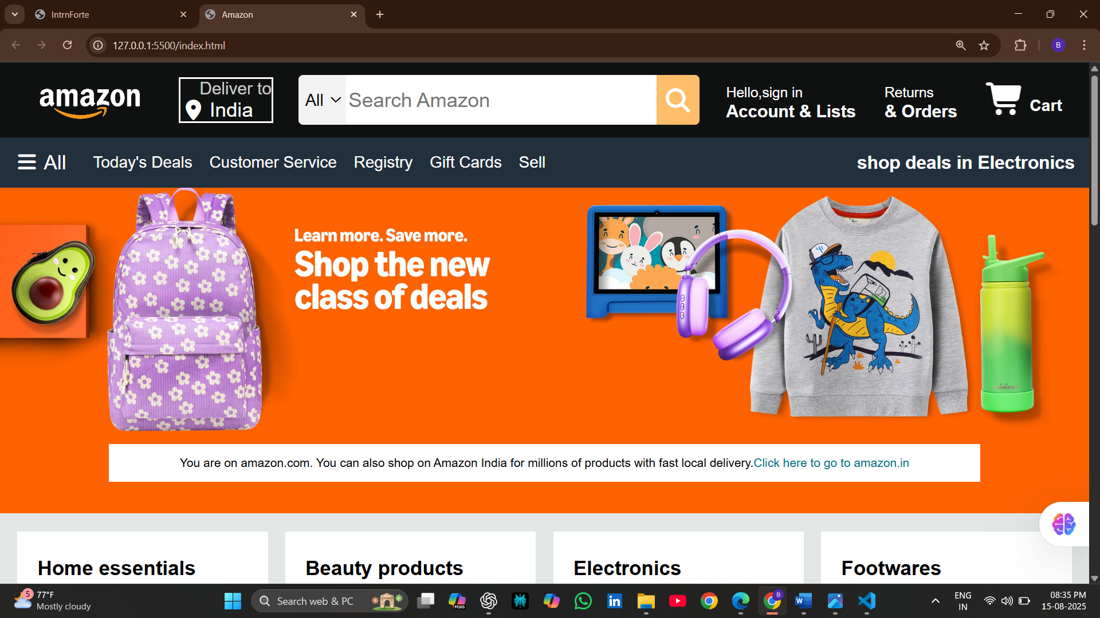

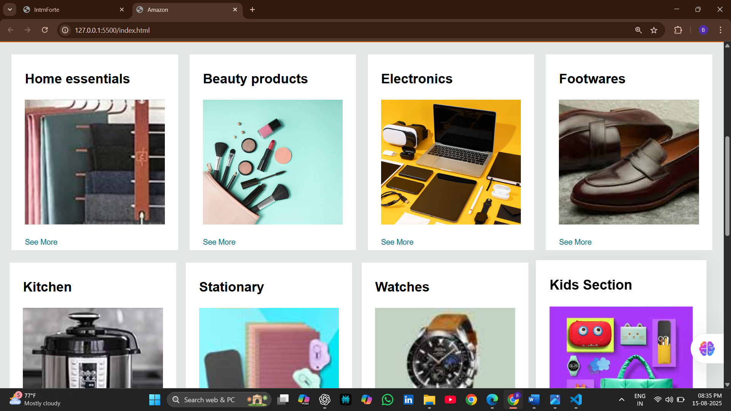 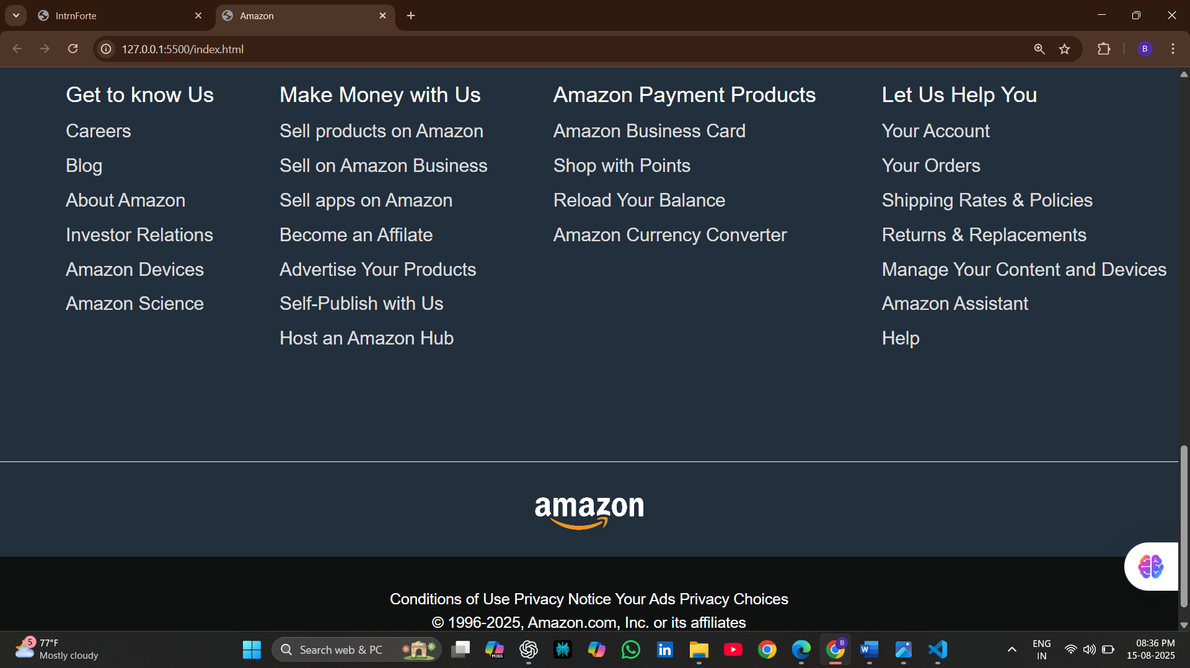

# 7. Challenges Faced

Example:  
• **Problem:** Implementing a simple cart system.  
**Solution:** Used JS sessions to temporarily store selected products before checkout.

# 8. Conclusion

The E-Commerce Listing Website provides a simple online platform for sellers to list products and buyers to browse and place orders. This project helped me understand the basics of Django for backend development, HTML/CSS for frontend design, and SQLite/MySQL for database handling. I also learned how to connect frontend and backend, manage user authentication, and apply responsive design techniques. Overall, it gave me valuable hands-on experience in building a beginner-level full-stack web application.

# 9. GitHub Repository

GitHub Link: [Add your repository link here]

Or attach the zipped source code files with the report.